**Working Title:** The genetic basis of multiple distinct flowering time cues in switchgrass (*Panicum virgatum*)

**Authors:** Alice MacQueen*, Li Zhang*, Jason Bonette, …who else? …, Tom Juenger

**Abstract**

Switchgrass (*Panicum virgatum*) is a perennial, warm-season species native to North America which has evolved into multiple divergent populations that vary in ploidy, morphology, and phenological timing. Its potential uses have expanded in the past few decades to include biofuels. Flowering time is a key life-history trait for biofuel production, as plants cease biomass accumulation upon completion of floral development. Here, we present evidence that photoperiodic sensitivity in switchgrass flowering time varies between genetic subpopulations using a diversity panel grown at eight field sites in the central United States spanning 17 degrees of latitude. We then map the genetic basis of flowering time in this population and in an independent four-way cross created from two highly divergent southern lowland and northern upland populations. We describe eight additive QTLs across these seven field sites with moderate effects on flowering, five of which had overlapping significant associations in the diversity panel. _sentence about major gene candidates found – prevalence of genes involved in __/expressed in __.

**Introduction**

*# Flowering and phenology importance to the plant*

*…this will be the first paragraph, as outlined above.*

*# Walkthrough of what is known about mechanisms controlling greenup and flowering in switchgrass*

Over the course of one season, switchgrass behaves as a determinate plant. It typically produces a single flush of tillers, which all become reproductive after a period of vegetative (leaf) development, and – critically – cease biomass accumulation upon completion of floral development (Van Esbroeck et al 2003). (Parrish and Fike 2005).

Spring growth is initiated by “adequate temperature” according to McMillan and Weiler (1959), with adequacy thought to be dependent on the cultivar (Parrish and Fike 2005). During vegetative growth, switchgrass phenology is closely correlated with growing degree days (GDD), the cumulative mean daily temperature less a base temperature (Madakadze et al 1998c; Sanderson and Wolf, 1995a, 1995b). A base temperature of 12 C for vegetative and reproductive development is commonly used for growth models (Kiniry et al 2005, Kinery et al 2008a, Berhman et al 2013). However, base temperatures vary by cultivar (Madakadze et al 2003) and there may be a photoperiod or vernalization mechanism rather than a temperature threshold *per se* that triggers spring growth (Parish and Fike 2005).

Switchgrass is considered a short-day plant that flowers when exposed to shortening days of a specific length (Benedict, 1940) and reproductive development is strongly linked to day-of-the year (Cornelius and Johnston, 1941; Eberhart and Newell, 1959; Hopkins et al., 1995a; Sanderson and Wolf, 1995a). However, the nature of switchgrass photoperiodicity may be genotype dependent – both northern and southern cultivars with distinctive upland and lowland ecotypes flowered under both 12 and 16 hour photoperiods, but flowering was delayed in the upland cultivar (Van Esbroeck et al 2003). Photoperiodicity likely differs with plant latitude of origin (Parish and Fike 2005). Moving plants from southern populations northward is thought to delay flowering, increasing leaf number and yields, while moving northern populations to southern latitudes is thought to hasten the transition to reproductive development, reducing vegetative growth and biomass yield (Sanderson et al 1996).

*# Management of switchgrass for biofuels is informed by an understanding of the biology underpinning plant responses to the environment.*

*P. virgatum* has substantial genetic and morphological diversity, with tetraploid and octoploid individuals (cite), three distinctive ecotypes, and three geographically distinct, deeply diverged genetic subpopulations within tetraploid individuals (Lovell et al 20XX). Upland individuals are smaller in stature than lowland individuals, other big differences (cite). There is also a coastal ecotype with lowland whole-plant characteristics and upland leaf characteristics (Lovell et al 20XX). This diversity, particularly the genetic differences in flowering date and photoperiod response, can be a point of exploitation in biomass crop breeding. Breeding for photoperiodic sensitivity in plants with earlier greenup dates may allow growers in the northern United States to take advantage of longer growing seasons, as photoperiod-sensitive strains will accumulate more biomass before flowering, contributing to higher biomass yields (cite?). Alternatively, breeding for cultivars with larger cumulative GDD requirements and reduced photoperiod sensitivity could increase the heat requirement needed for switchgrass development and stabilize switchgrass biomass yields at higher levels, which could help offset the negative impacts of climate warming (cite). However, despite substantial study of the mechanisms controlling switchgrass development, genetics of flowering and prediction equations with broad application remain elusive.

*# Here, we do xxx, yyy, zzz.*

Here, we grow and phenotype a diversity panel of 978 distinct switchgrass genotypes, clonal replicates of which were planted at eight common garden sites across 17 degrees of latitude. We use this panel to interrogate environmental mechanisms controlling greenup and flowering. We then use a F2 cross between individuals from the most distinctive subpopulations for flowering response to dissect the genetics of flowering in these groups. Finally, we combine the results from this cross with genome-wide association results from the diversity panel to narrow in on candidate genes affecting flowering date. Taken together, our results allow us to describe the distinct genes and alleles controlling flowering across multiple distinct switchgrass populations.

**Materials and Methods**

Diversity panel and Single Nucleotide Polymorphism Dataset  
 Panel collection, propagation, cultivation, and sequencing  
 Panel ploidy assessment, ecotype classification, and phenotyping  
 Genome-wide association mapping  
        Analysis of correlated SNP effects on phenotypes at multiple sites

Fourway cross and Quantitative Trait Locus Dataset  
Creation, propagation, cultivation, and phenotyping  
A four-way population (801 F2 individuals) with their grandparents and F1 hybrid parents was clonally propagated 10 times in 3.8L pots at the Brackenridge Field Laboratory, Austin, TX in 2014-2015 and transplanted to 10 common garden sites covering 17 degrees of latitude from South Texas to South Dakota in May-July of 2015. The details of creation of the population can be found in Milano et al. (2016). Briefly, the population was developed by initial cross between AP13 (A) x DAC6 (B) and WBC3 (C) x VS16 (D), the F1 hybrids of each of those crosses were then intercrossed reciprocally to create the four-way outbred population, 801 F2 individuals. The four grandparents were derived from highly divergent southern lowland and northern upland ecotypes: AP13, an early flowering Gulf individual, and WBC, a late flowering Gulf individual, DAC, an early flowering Midwest individual, VS16, a late flowering Midwest individual. The details of the 10 common garden sites can be found in Lowry et al. (2019). Briefly, each field was covered with one layer of weed barrier cloth, and holes were cut into the weed cloth in a honeycomb design. Plants were randomized into the holes, with each plant having four nearest neighbors located 1.56m away from each other. A row of border plants which were derived from rhizome plugs of approximately 10-year-old Alamo switchgrass were planted at every edge position to prevent edge effects. Plants were well-watered in 2015 to facilitate establishment.

Phenology data, including greenup and flowering time, have been recorded from 2016 to 2019 for the four-way population at each site. Greenup (GR50) was recorded as the day of the year when 50% of the tillers from the crown on the plant turned green, flowering (FL50) was recorded as the day of the year when 50% of the plant tillers had panicles undergoing anthesis. Additionally, cumulative growing degree days (GDD) from GR50 to FL50 was calculated as GDD = $\sum_{GR50}^{FL50}{max(T_{mean}-T_{base}, 0)}$, where Tmean is the daily average temperature, Tbase is the base temperature of 12 °C for switchgrass (Kiniry et al 2005, Behrman 2013). On a specific day, if Tmean is less than Tbase, the GDD for that day is 0; if Tmean is bigger than Tbase, the GDD for that day is the difference between Tmean and Tbase. To be comparable and consistent with the diversity panel, only 2019 phenology data of the four-way population from the same seven common garden sites were used in this study.

Sequencing and QTL mapping

Illumina fragment paired end libraries, representing each of the four grandparents (A: AP13, B: DAC; C: WBC; D: VS16) were aligned to the *Panicum virgatum* reference genome v5) with bwa *mem* (Li and Durbin 2009). Details on the genetic map construction, map polishing and fine-scale reordering can be accessed on <https://datadryad.org/stash/dataset/doi:10.5061/dryad.ghx3ffbjv>.

Narrow-sense heritability (h2) for each phenotype (GR50, FL50, GDD) at each field site was estimated using the additive kinship matrix based on marker genotypic information. The process was accomplished via the ‘sommer’ package (Covarrubias-Pazaran, 2020) in R (2020). Briefly, we used a multivariate mixed model (mmer) that takes the kinship matrix and other random incidence matrices to estimate the variance components for each phenotype at each field, and calculates h2 as the proportion of additive genetic variance to the total variance.

QTL mapping was conducted with R/qtl2 (Broman, 2020). Specifically, we performed a genome scan with a linear mixed model accounting for the relationships among individuals (i.e., kinship matrix) and the environmental covariates (i.e., field sites). The full model can be expressed as: phenotype = µ + G + E + G x E + e, where µ is the population mean, G is the genetic effect (i.e., kinship matrix), E is the environmental effects (i.e., field sites), G x E is the interaction between genetic and environmental effects, and e is the error term. The genome scan was accomplished through ‘scan1’ function. The statistical significance of the genome scan was established by performing a stratified (i.e., stratifying on field sites) permutation test (n=1000) using ‘scan1perm’ function. The estimated QTL effect was obtained using ‘scan1coef’ function in R/qtl2.

**Candidate gene search**

**Results**

*Diversity panel captures the range of phenological responses across the common gardens*

In 2019, we grew and phenotyped a diversity panel of 978 distinct, clonally propagated switchgrass genotypes at eight common gardens. These common gardens cover the majority of the latitudinal and climatic range of switchgrass and therefore capture the most comprehensive picture to date of genotype-specific environmental plasticity, or genotype-by-environment interactions, in this species. We scored plant green up and flowering at these common gardens every three days. Given the deep genetic divergence within this species, we divided these switchgrass genotypes into five categories: tetraploid individuals in the Atlantic, Midwest, and Gulf genetic subpopulations (Lovell et al 202X), admixed/uncategorized tetraploid individuals, and octoploid individuals. We then explored the overall patterns of greenup and flowering within these five subpopulations.

We first evaluated the evidence that switchgrass photoperiodicity was genotype dependent – specifically, that switchgrass genotypes flowered when exposed to shortening days of a specific length. Many genotypes flowered while days were lengthening at the three Texas sites (Figure 1). At these three sites, only individuals from the Gulf subpopulation consistently flowered when days were shortening (Figure 1; 85.3%, 94%, 99.5%). Our data thus only supports a consistent flowering time cue of shortening days within the Gulf subpopulation, while response to this cue may be segregating within the Atlantic subpopulation and within 8X individuals, and is absent or rare in Midwest individuals.

**Figure 1.** *Many genotypes do not use a shortening day photoperiodicity cue at the three Texas (TX) common garden sites. Bars represent the number of distinct genotypes that had 50% of tillers flowering before the summer solstice (when days were lengthening) or after the summer solstice (when days were shortening). Colors represent the five categories we grouped genotypes into: tetraploid individuals in the Atlantic, Midwest, and Gulf genetic subpopulations, admixed/uncategorized tetraploid individuals, and octoploid individuals.*

We then looked for a specific day length that triggered flowering during shortening days. For plants with sequenced genomes, we modelled daylength at flowering as a function of common garden and kinship matrix, both as random effects. To ensure we detected a daylength cue for shortening days, we removed daylength values for genotypes that flowered during lengthening days. The heritability for daylength at flowering during shortening days was 12%, while the heritability for flowering as a Julian date for the same set of individuals was 23.7% (Supplementary Table: Variance Components analysis). Thus, there was little evidence that the heritable response to flowering was due to any specific day length during shortening days in our common gardens. Instead, the flowering photoperiodicity cue appeared to be only exposure to shortening days.

Next, we evaluated whether photoperiodicity, defined simply as exposure to shortening days, differed by plant latitude of origin (Parish and Fike 2005). We observed a strong signal of latitude of origin on whether plants grown in Texas common gardens flowered in lengthening or shortening days (binomial glm, *Pr* < 2x10-16, Supp. Figure 1). The majority of plants from latitudes of origin below 35 degrees did not flower until days were shortening at the Texas sites, while the majority of plants from latitudes of origin above 38 degrees flowered while days were lengthening. Interestingly, the Oklahoma (OK) site, our first common garden at which most genotypes flowered during shortening days, was at ~36 degrees of latitude; in contrast, the three sites where a photoperiod cue was evident were below 32 degrees of latitude. At our common gardens in 2019, plants grown at latitudes >35 degrees did not have sufficient vegetative growth to flower before the summer solstice, and thus were not competent to repress flowering during lengthening days. As this is a common feature of growing seasons at these latitudes, we suggest that plants from more northern latitudes have evolved a flowering time response to a separate, non-photoperiod based environmental cue.

**Supplementary Figure 1.** *Latitude of origin correlates with flowering response to an environmental cue of shortening day length. Bars represent the number of distinct genotypes that had 50% of tillers flowering before the summer solstice (when days were lengthening) or after the summer solstice (when days were shortening). Colors represent the five categories we grouped genotypes into: tetraploid individuals in the Atlantic, Midwest, and Gulf genetic subpopulations, admixed/uncategorized tetraploid individuals, and octoploid individuals.*

Because switchgrass phenology is closely correlated with growing degree days (GDD) during vegetative growth, to test for a temperature-based environmental cue for flowering, we evaluated flowering date as a function of cumulative GDD between plant green up and flowering, using a base temperature of 12 C (Kiniry et al 2005, Behrman 2013). We then modelled GDD as a function of subpopulation and the interaction between subpopulation and latitude of origin, both as random effects. To avoid confounding with a photoperiod-based environmental cue, we removed GDD values for genotypes predicted to have a photoperiod cue at the four common gardens south of 38 degrees latitude. Including these GDD values substantially increased the residual variance for photoperiod sensitive individuals at these sites (data not shown//in supplement). Subpopulation explained most of the variation in flowering as a function of GDD (% Varsubpop = 85.9%). Predicted values of GDD necessary for flowering were largest for the Gulf subpopulation (1056; 95% CI 973-1099), smallest for the Midwest (667; 95% CI 517 – 814) and intermediate for the other three groups (741 (599-1019); 776 (483-1195); 747 (573 – 1043); Supplementary table of effects). The heritability for GDD at flowering for photoperiod insensitive, sequenced individuals was 30%, while the heritability for flowering as a Julian date for the same set of individuals was 10.8% (Supplementary Table: Variance Components analysis).

If flowering date is frequently a function of GDD in switchgrass, this offers and explanation for observations that moving southern populations northwards delays flowering, and moving northern populations south hastens flowering (Sanderson et al 1996). We tested whether subpopulation flowering as a function of GDD varied significantly by latitude of origin. The Midwest subpopulation response to GDD varied significantly by latitude of origin, with plants from the northernmost 20% of the range flowering at an average GDD of 568, and plants from the southernmost 20% of the range flowering at an average GDD of 779. In contrast, the southernmost and northernmost 20% of the Gulf plants differed only slightly in GDD (1008 vs 1090). Taken together, these data support latitude-of-origin based, low GDD cue for flowering in the Midwest subpopulation, and a consistent, high GDD cue for flowering in the Gulf subpopulation that is superseded by a photoperiod cue, with both cues segregating in the Atlantic subpopulation by latitude of origin.

*Fourway cross breaks up genetics of flowering for the two most distinctive subpopulations*

The Midwest and Gulf subpopulations had the most distinct phenological responses of all five subpopulations across our common gardens and appeared to flower in response to two distinct environmental cues. To analyze the genes and alleles underlying the phenological responses in these subpopulations, we analyzed flowering date in an F2 cross between four individuals, two Midwest and two Gulf individuals. The parents of this cross were DAC, an early flowering Midwest individual, VS16, a late flowering Midwest individual, AP13, an early flowering Gulf individual, and WBC, a late flowering Gulf individual (Supplementary Figure X.). We made F1 crosses of the two early flowering individuals, AP13xDAC, and the two late flowering individuals, WBCxVS16. We then clonally propagated and planted the four parents, the two F1 individuals (AP13xDAC, and VS16xWBC), and 801 F2 individuals at eight field sites, then recorded greenup and flowering date every three days for the 2016-2019 seasons.

We first compared the 2019 flowering dates of F1 individuals to the parents and to those of the diversity panel to determine dominance of the two flowering date environmental cues. Though there was an average difference in flowering date of 17 days between the two F1 crosses, all F1 individuals flowered at similar dates as the Midwest parents each year, and Midwest subpopulation individuals in general in 2019 (Figure 2; early and late F1s flowered 8.1 +/- 8.1 and 7.9 +/- 13.3 days behind their F0 parents). In addition, neither F1 flowered consistently in shortening days in 2016 through 2019. These data indicated that the lower GDD environmental cue for flowering in the Midwest subpopulation was dominant to the photoperiod response and the higher GDD environmental cue for flowering in the Gulf subpopulation. <For a trait that we expect to be under polygenic control with many genes of small effect, the almost complete dominance of the Midwest phenotype is surprising. There’s been a northward range expansion in switchgrass after the last glacial maxima (cite), and a dominant lower GDD flowering time cue would have been tremendously selectively advantageous during this range expansion event (*theory cite? Tom has mentioned this*).>

****Figure 2.** *F1 flowering dates indicate dominance of Midwest subpopulation flowering environmental cues. Vertical dashed lines show F1 flowering dates in 2019 for two Midwest x Gulf crosses. Violin plots show the distributions of flowering dates in the Midwest and Gulf subpopulations in the diversity panel. Bold yellow vertical line indicates the summer solstice. 2018 data is shown for the TX3 site, as 2019 data was not collected for this cross at this common garden.*

To determine if Gulf subpopulation flowering date phenotypes were recoverable in F2 individuals, we compared the flowering date distributions of F2 individuals to those of the parents. Very few F2 phenotypes recaptured the Gulf subpopulation parent phenotypes: only 15.7% of F2 flowering dates across all sites and years occurred on or after the minimum flowering date for one or both Gulf parents in that common garden and year. Long tails for the F2 flowering date distributions were primarily observed at TX2 and TX3, where there was the potential to isolate QTL that affected the ability of the plant to flower in response to a photoperiod cue (Figure 3, or as supplement?). F2 individuals at TX2 and TX3 also had flowering dates similar to late flowering Midwest individuals to early- to mid-range flowering Gulf individuals (Supplementary Figure). In contrast, at the northern five sites and at Kingsville, F2 individuals had similar flowering dates as individuals from the Midwest subpopulation. Thus, at the northern five sites, we expected to find QTL controlling flowering date from the Midwest subpopulation, potentially by affecting the cumulative GDD requirements for the plant before flowering.

**Figure 3.** *Distribution of flowering date for F2 individuals (violin plots) relative to parent plants (x’s).*

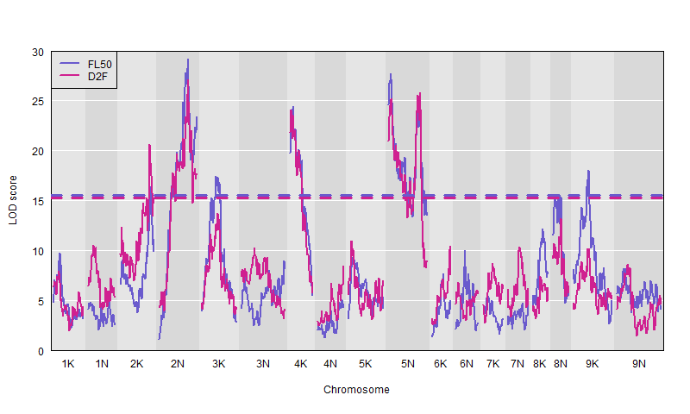We next analyzed the genetics of greenup and flowering in 2019 for seven fourway sites. We anticipated finding QTL at the northern common gardens that distinguished between early and late-flowering Midwestern alleles, while the TX2 common garden offered the potential to examine effects of Gulf alleles. There were no significant QTL for greenup. There were eight QTL for flowering date in the fourway cross; the largest QTL were on Chr02N, Chr04K, and Chr05N. All eight QTL exhibited significant GxE between common garden sites. Our cross design allowed us to estimate allelic effects of alleles from both F1 individuals. In the early flowering allele set, AxB, at TX2, five of eight lowland alleles delayed flowering date. In the CxD cross at TX2, four of eight lowland alleles delayed flowering date – four of the same five regions that delayed flowering date in the AxB cross. These effects were consistent with the observed order of flowering in the F0 and F1. We therefore hypothesized that these regions: Chr02N, Chr04K, Chr05N, (Chr08N), and Chr09K were important regions affecting flowering in the Gulf subpopulation. At the northern sites, because of the dominance of Midwest phenotypes and alleles that we observed, we compared effects of the Midwest allele from the early and late F1 cross. For 28 site by QTL combinations for the AxB early flowering alleles, the Midwest allele was accelerating flowering. For 16 site by QTL combinations for the CxD late flowering alleles, the Midwest allele was accelerating flowering, and for 2 site by QTL the upland allele was delaying flowering. These effects were also consistent with the observed order of flowering in the F0 and F1. All eight QTL affected flowering date for at least one northern site for both the early and late flowering allele sets. Thus, we hypothesized that all eight regions were important regions affecting flowering in the Midwest subpopulation. 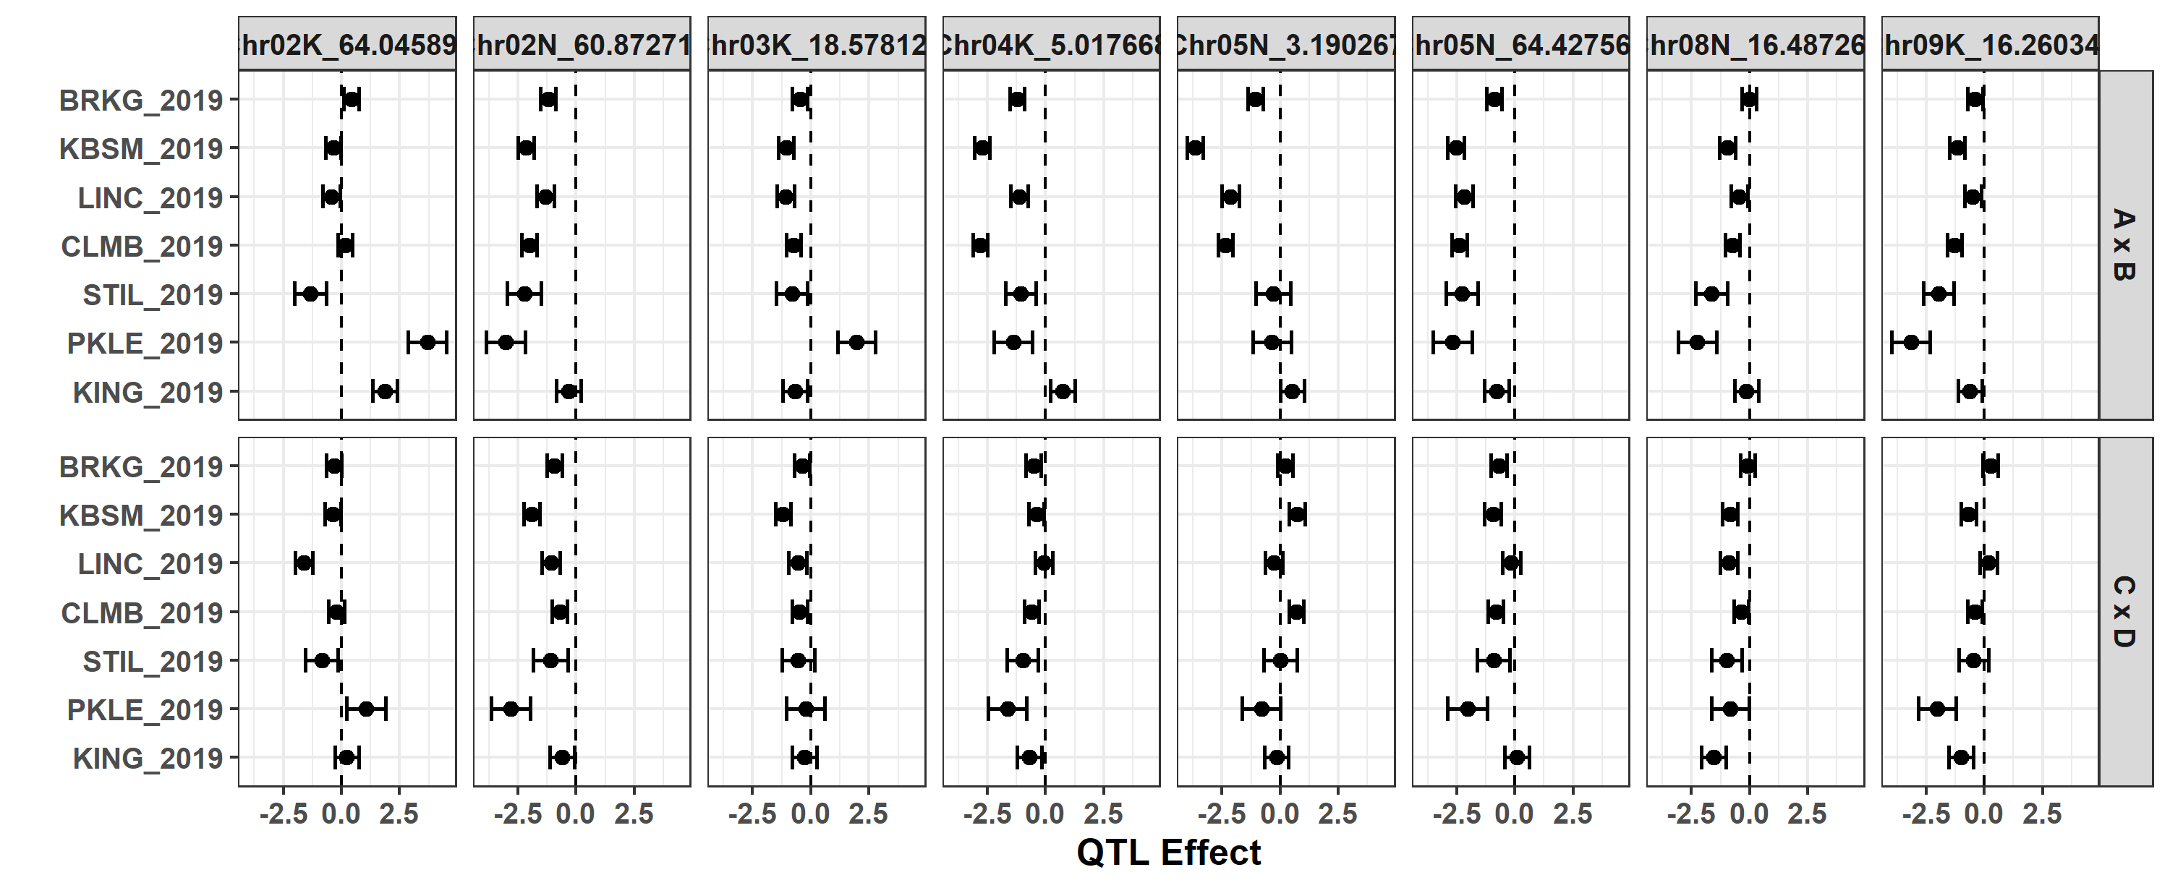

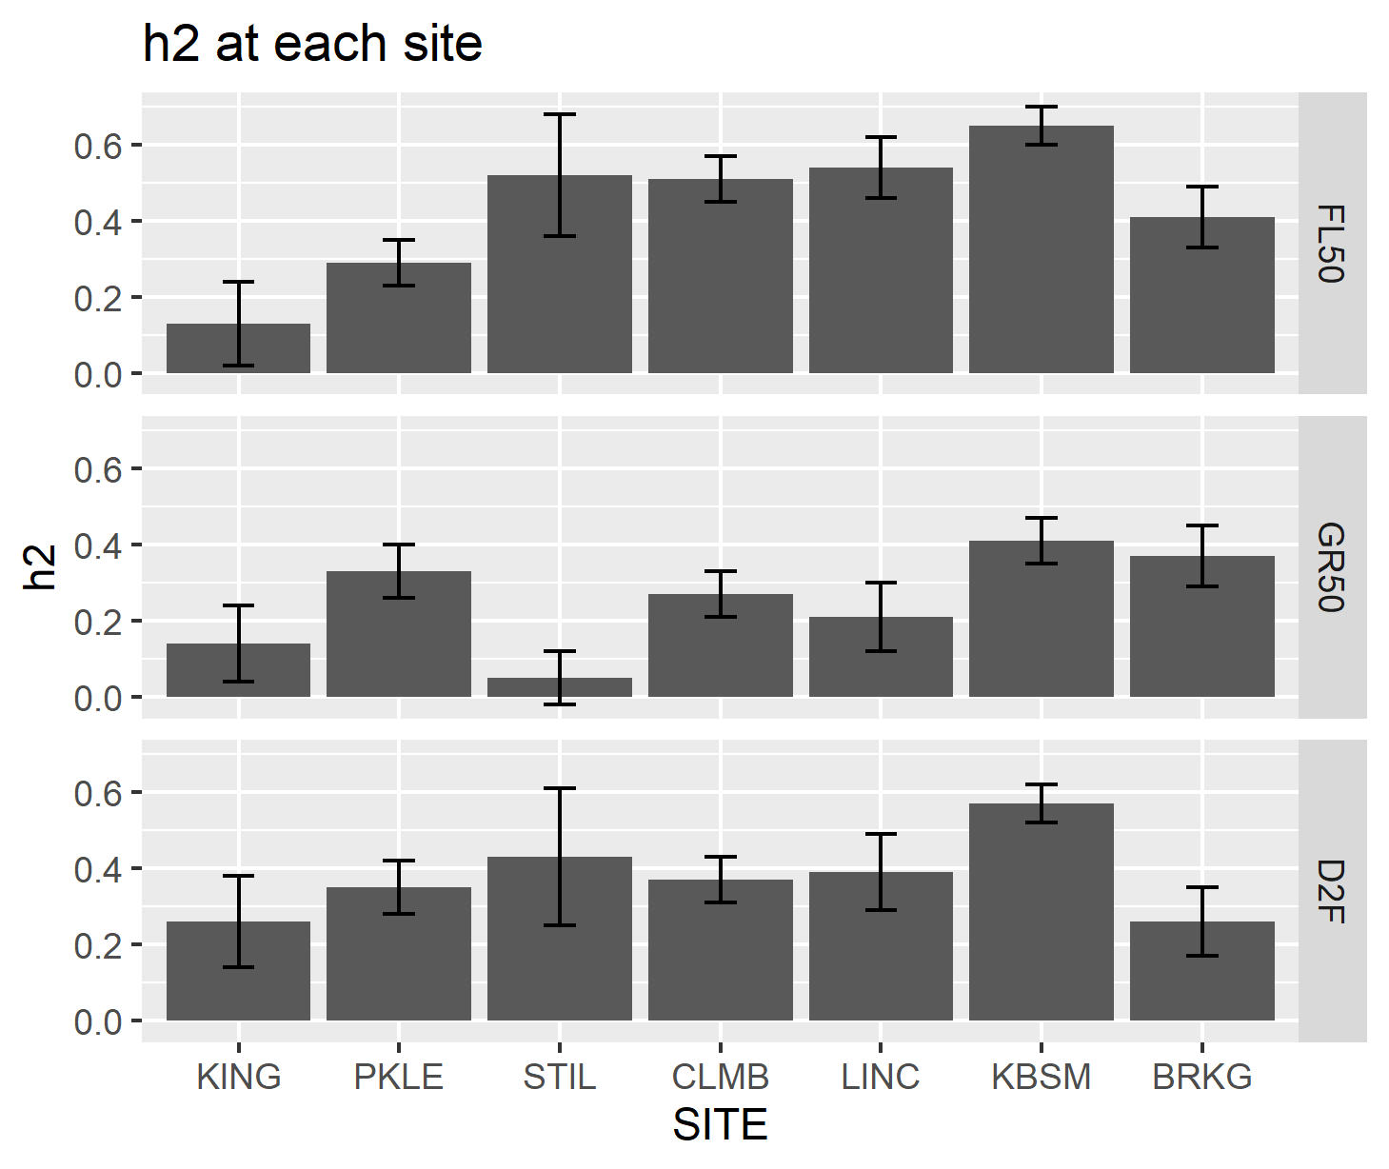Kingsville (TX1) represents a marked departure from the temperate growth habits at the other nine sites. In general, heritability for flowering was lowest at TX1 in both the diversity panel and the fourway cross, indicating a larger effect of environment on phenotypic variance at this site. At this site, 2 AxB Midwest QTL accelerated flowering, and 2 delayed flowering. In CxD, alleles at four Midwest QTL accelerated flowering.

*Genome wide association identifies candidates affecting flowering in fourway QTL intervals*

Though QTLs detected using the fourway cross are too coarse to be informative about gene identity by themselves, combining linkage and association mapping can outperform each method used in isolation (cite Brachi, others?). We therefore conducted GWAS on greenup and flowering date at seven common garden sites for individuals from both the Midwest and Gulf subpopulation. We then analyzed the allelic effects across common garden sites for the top XK SNPs using mash. Using this data, we focused on identifying associations in or near the important QTL regions for flowering date from the fourway cross, as well as the population that allele was found within and the effect that that SNP had across sites.

Five of the eight QTL – the four largest QTL, and all five QTL that we hypothesized affected flowering in the Gulf subpopulation – colocalized with one or more of the top 25 mash hits. Discussion of candidate genes, where they are in the QTL interval, what the effects look like in mash, what subpops they are segregating in, for:

* Candidate on Chr02N
* Candidate on Chr04K
* Candidate on Chr05N 4.3 Mb
* Candidate on Chr05N 64.4 Mb
* Candidate on Chr08N

*Possible Genomic Prediction Section*

* I don’t know how to tie genomic prediction in here. Ideally we’d perhaps have information on which parts of the genome being Midwestern vs Gulf would make you sensitive to photoperiod cues, and which parts affect how much cumulative GDD you need, if you’re not sensitive to photoperiod cues. That would be a nice way to bring this full circle.

**Discussion**

* Possible reasons why we didn’t find candidates in GWAS for other three QTL intervals: false negatives, type of allele shifts we are testing here vs the fourway, other things
* And what are other types of region we can detect with GWAS that we couldn’t detect in our fourway? Particularly differences between Gulf alleles… maybe offer up Gulf specific GWAS/mash here. Or GWAS on any individual that is tetraploid and looks like it’s photoperiod sensitive – including some admixed and Atlantic individuals. As an idea.
* Want to bring back discussion of environmental cues… may be able to lead in to this by talking about which subpopulations are segregating for these things.

**References**

Li H, Durbin R. 2009. Fast and accurate short read alignment with Burrows–Wheeler transform. Bioinformatics 25:1754-1760.

Parrish DJ, Fike JH. 2005. The Biology and Agronomy of Switchgrass for Biofuels. Critical Reviews in Plant Sciences 24:423-459.

Tables & Figures, Maybe Supplementary

|  |  |  |  |  |  |  |  |
| --- | --- | --- | --- | --- | --- | --- | --- |
| Site | Latitude | Genotypes that flowered while: | 4X | 8X | Atlantic | Gulf | Midwest |
| Kingsville, TX, USDA/PMC | 27.55 | days lengthening | 9 | 8 | 44 | 23 | 23 |
| Kingsville, TX, USDA/PMC | 27.55 | days shortening | 11 | 4 | 18 | 134 | 1 |
| Austin, TX, UT PRC | 30.38 | days lengthening | 19 | 167 | 206 | 11 | 115 |
| Austin, TX, UT PRC | 30.38 | days shortening | 12 | 66 | 56 | 173 | 6 |
| Temple, TX, USDA/ARS | 31.04 | days lengthening | 8 | 7 | 45 | 1 | 46 |
| Temple, TX, USDA/ARS | 31.04 | days shortening | 15 | 6 | 62 | 193 | 15 |
| Stillwater, OK, OSU | 35.99 | days lengthening | 1 | 0 | 2 | 0 | 2 |
| Stillwater, OK, OSU | 35.99 | days shortening | 18 | 8 | 86 | 83 | 52 |
| Columbia, MO, MU BRF | 38.90 | days lengthening | 0 | 3 | 0 | 0 | 6 |
| Columbia, MO, MU BRF | 38.90 | days shortening | 31 | 206 | 228 | 149 | 113 |
| Lincoln, NE, UNL ARF | 41.15 | days shortening | 18 | 13 | 123 | 66 | 67 |
| Hickory Corners, MI, KBS | 42.42 | days lengthening | 0 | 1 | 0 | 0 | 0 |
| Hickory Corners, MI, KBS | 42.42 | days shortening | 36 | 181 | 199 | 198 | 109 |
| Brookings, SD, SDSU | 44.31 | days shortening | 15 | 12 | 109 | 73 | 63 |

**Supplementary Figure X.** Average flowering date from 2016 – 2019 for the four parents of the fourway cross, compared to the 2019 distribution of flowering date for the Gulf and Midwest subpopulations. The two Midwest parents are DAC and VS16, and the two Gulf parents are AP13 and WBC. Bold yellow line indicates the summer solstice.

However, cumulative GDD was not sufficient to explain the variation in flowering time in the Gulf subpopulation. Instead, we hypothesized that the Gulf subpopulation also used a photoperiod cue, given the imperfect relationship between GDD, photothermal time, and flowering in the Gulf subpopulation, and the presence of a relationship between latitude of common A screenshot of a cell phone
garden and flowering time based on cumulative GDD.

Cumulative GDD vs photoperiodicity as a function of each plant’s location of origin.